(Approx. 663 words)

Try the Presenter View in PowerPoint
By Nancy DeMarte, 1st Vice President, Sarasota Technology User Group, FL
April 2016 issue, Sarasota Technology Monitor
www.thestug.org
ndemarte (at) verizon.net

One of the most helpful new features in Microsoft’s PowerPoint 2013 is a tool for people who do presentations. At first, I thought an article on this topic might be useless to anyone except a professional presenter or teacher. But on second thought, anyone who puts forth the effort to build a PowerPoint presentation, like a travelogue from a recent trip or a biographical show for a family reunion or wedding reception, can make good use of this new feature, called the Presenter View.

The purpose of the Presenter View is to give the speaker more control over the presentation. For years, I’ve used PowerPoint presentations in classes, meetings, and other occasions. More than once, I found myself in the awkward position of finishing my discussion of the slide on the screen and then going on to say what I intended to say about the next slide before I even displayed it. With Presenter View, I can avoid that problem. Here is an example of the Presenter View of a show from one of my classes. This is what I see.

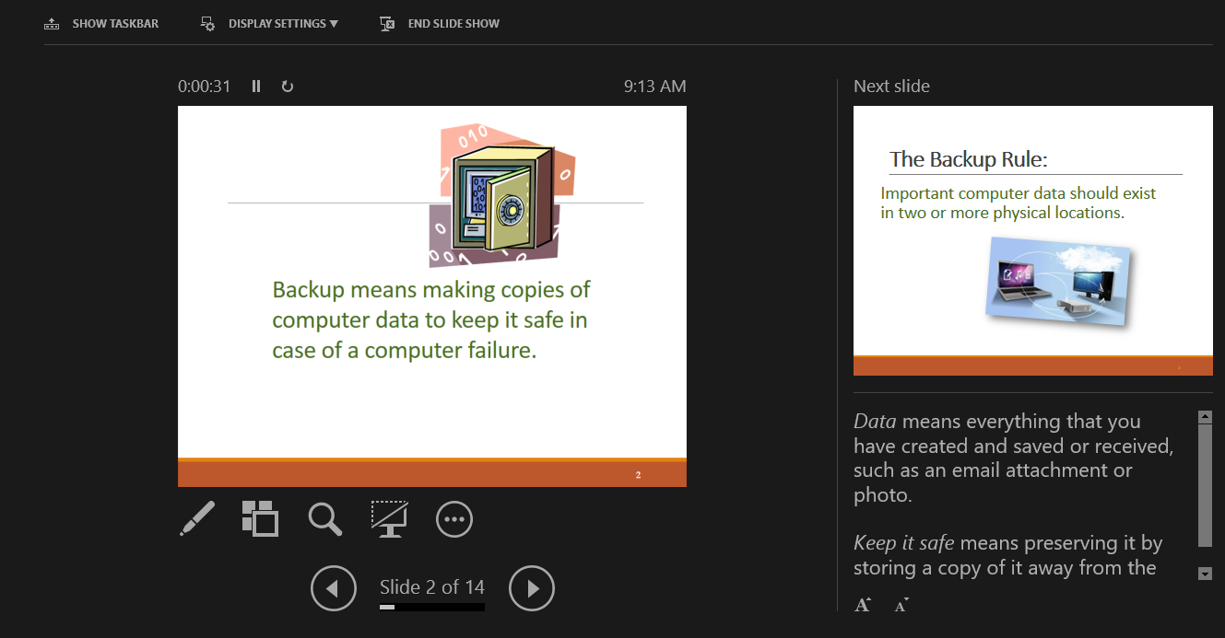

The only slide the audience sees is the large one; the small slide is the next one in the show. Beneath the Next Slide are notes I wrote to accompany the current slide. I set the font large enough to see at a glance. The top of the screen contains three often-used commands, visible only to the presenter. Show Taskbar opens the computer’s taskbar along the bottom, making it easy for me to open another app or access the Internet, if necessary, without leaving the presentation. Display Settings lets me leave the Presenter View or switch it with the normal view, and End Show provides an alternative to the Escape (Esc) key to complete the show.

Other tools are available around the large slide. On the top left is a Timer which starts when a new slide is displayed. This helps me manage my time so I don’t over-discuss a slide. Next to it is a Pause button and a curved arrow icon which restarts the timer. The actual time displays on the top right. Below the current slide is a pen which can be used as a laser pointer, highlighter, pen to draw on the slide in a choice of colors, or an eraser. The next icon, a square with boxes behind it, when clicked, shows all the slides in the presentation in the Slide Sorter view. This can be useful if I decide to skip a slide or change the slide order during the presentation. The magnifying glass lets me zoom in on a section of a slide to focus audience attention there. I can turn the screen black or white with the next icon that resembles a computer monitor. I might use this if topic comes up in discussion that is unrelated to the current slide, and I want to eliminate its distraction. The circle icon with three dots (a new Microsoft settings icon which appears in many apps) contains settings like Hide Presenter View, End Show, and Help.

To use Presenter View, check the box next to “Use Presenter View” on the Slide Show tab – Monitors group, then begin your show. Some people, however, find using this view disconcerting at first. Fortunately, I can practice using the Presenter View even when the show is not being projected. Click the Slide Show tab, then click “From the Beginning” in the Start Slide Show group, right click the first slide, and choose “Show Presenter View” from the menu. Now I can practice using it without any audience pressure.

Although I’m a longtime PowerPoint user, adapting to this new view took a little practice. Now that I feel comfortable with it, I appreciate how well it helps me avoid unexpected problems during my presentations.

